**Outline Project Investment Appraisal**

**Inverness water supply resilience**

|  |  |  |  |  |  |
| --- | --- | --- | --- | --- | --- |
| Version | Purpose | Prepared | Checked | Approved | Date |
| 2.0 | For Director review | B McCarthy | A Scott | S Parsons | Aug 2020 |

**Contents**

1. Introduction 3

2. Need for Investment 3

3. Options Appraisal 6

4. Recommendation 9

Appendix 1 – Water supply reliability assessment 10

Appendix 2 – Cost and carbon estimating 25

## Introduction

This paper sets out our updated assessment of investment required to improve the resilience of water supplies to the Inverness area. The Inverness water supply resilience project was commenced in 2014 and is now approaching stage of commitment at a cost of between £35 and £40million, a £15-£20million increase on the original estimate. Given this significant investment, and cost increase, it is important that we re-appraise the investment to confirm if the selected option remains appropriate.

## Need for Investment

**Customer & Stakeholder perspective**

Our customer research tells us that they expect a reliable supply and generally could not cope with supply interruption lasting longer than 48-72 hours. We have no specific research that understands our customers’ tolerance to water supply restrictions in periods of dry weather. We assume that customers would expect us to address any known risk that would compromise the current reliability of supply. Our policy standard for reporting Security of Supply (SOSI) under Overall Performance Assessment (OPA) is a 2.5% chance in any year of supply restrictions.

We have not undertaken specific research with the community of Inverness to ask if they would accept an increase in water supply risk or the local environment to avoid carbon and investment costs.

Our Controlled Abstractions Regulations (CAR) Licence requires a daily compensation flow of 4.5Ml/d from Loch Duntelchaig to protect the ecological status of the river downstream. We are also required to provide passage for fish through the fish pass except when the flow downstream is naturally low. We have not yet discussed in detail the acceptability or impacts/benefits of breaching any of these licence requirements with SEPA.

Scottish Government have identified in the Third National Planning Framework that Inverness is Scotland’s fastest growing city. The Framework sets out the strategic infrastructure priorities in Scotland, one of which is the dualling of the A96 between Inverness and Aberdeen by 2030. Therefore, we expect to see significant growth to the east of Inverness as this and other improved transport corridors are established and for some time thereafter.

We have a number of confirmed developer commitments to build in the area and a number of enquiries that lead us to believe that demand growth will continue over the next [10-20] years and possibly longer.

**Technical perspective**

Inverness (Ashie) WTW supplies water to around 75,000 population and a number of small business users. There are two large business users, Raigmore hospital 0.5Ml/d and Bairds Malt 0.7Ml/d, who have a planned business expansion underway that will almost double their demand.

Leakage is currently at the short run economic level of 4.9Ml/d (8.8 m3/km of main). We believe that if economically beneficial compared to other investments this can be reduced by a further 2Ml/d consistent with the lowest average levels (5 m3/km) seen in UK water companies.

The per capital consumption (PCC) in the zone 175l/h/d, slightly above the Scotland average of 166l/h/d, which is consistent with the average non-metered consumption across the UK water companies. The lowest reported average PCC across UK is 135l/h/d in companies that have high meter penetration.

The WTW is situated above the city supplying water by gravity and takes raw water from two lochs, Loch Duntelchaig and Loch Ashie both of which are pumped to the Inverness WTW through low lift raw water pumps. Loch Duntelchaig is a large volume source, restricted in use by the depth of its fishpass and supply intakes. Loch Ashie is a much smaller source, but is used to supply 15% of demand in order to provide an acceptable WTW blend. The WTW is designed to treat 38Ml/d.

The supply capacity is constrained by the availability of raw water at Loch Duntelchaig by CAR licence requirements, currently calculated using the fish pass / compensation level as a constraint. We do have the ability to use further storage down to the intake level but we would have to siphon or pump (cost £200-300k) compensation flows and fish passage would not be achieved. Our policy for security of supply requires that under normal operation all supplies have no more than a 2.5% chance in any year of source failure. Our supply demand balance assessment of the Inverness supply shows that, based on 100 years of historic data, using the fish pass level as a storage constraint and including headroom, we do not meet our policy level of service.

At current demand our hydrological assessment (Appendix 1) demonstrates that the supply is is sensitive to multi-year dry periods such as occurred 1970-79. Our water resource modelling has shown that with current demand, there is a 2 to 5% risk that we would require temporary under-pumping at Loch Duntelchaig to avoid supply failure and this would be in place for around 5 years (cost £300-500k pa). Our modelling also shows that there is greater than 10% risk that fish passage will be prevented and compensation flows will require to be pumped for a period of up to 10 years.

Over the past 10 years we have seen a 1.8Ml/d increase in demand from new household properties (average 500 houses per year) which has been offset by leakage reduction. Our Developer Management team estimate that based on known development and assessment of current enquiries this rate could be 50% higher going forward for the next ten years. One of the uncertainties is the development rates beyond 2030, we have assumed two approaches ongoing development at historic rates and ongoing development at higher rates shown in current developer enquires.

If this demand growth continues without improvement to supply resilience we will increase the likelihood of supply restrictions and environmental impacts. The forecast rate of deterioration depends on what assumptions we make regarding ongoing demand increase and climate change impacts. Our climate change modelling suggests that the yield of the current sources could reduce by 1.4Ml/d (median) to 4.9 Ml/d (10 percentile) over the next 20 years and 2.2 Ml/d (median) to 7.9 Ml/d (10 percentile) over the next 50 years.

Our worst-case projection without action is based on the predicted high growth rate continuing indefinitely, and the 10 percentile climate change impact on water resource availability. In this scenario there is a 25% chance of the loch being below the intake level resulting in under-pumping of water supply being required before 2028 and a 75% chance of this being required by 2032. Fish passage will have ceased ahead of these dates and compensation will have to be under-pumped.

Although we could technically manage the loch being drawn down below the intake (as described in our drought management plan) in the longer term, the drought management plan becomes unsustainable as the predicted demand exceeds the net long term inflow to the reservoir.

Our hydrological assessment shows that when total raw water demand increases to around 30Ml/d (currently demand is at 25 Ml/d), the average inflows to Loch Duntelchaig will be exceeded and the loch is effectively emptying over time thereafter. Depending on growth rates and climate change impacts this could occur anytime between 2031 and 2043.

At present the Inverness WTW supply has not been identified for any significant water quality improvements and, as it is less than 20 years old, unlikely to have a need for a major rebuild of key civils structures for many years. The treatment works is capable of treating up to 38Ml/d so has spare capacity to meet growth demands and provide resilience to surrounding supplies if required.

The Inverness system at present has no significant inter-connectivity with other surrounding supplies from Assynt and Glenconvinth WTW’s.

Figure 1: Inverness supply location and surrounding systems

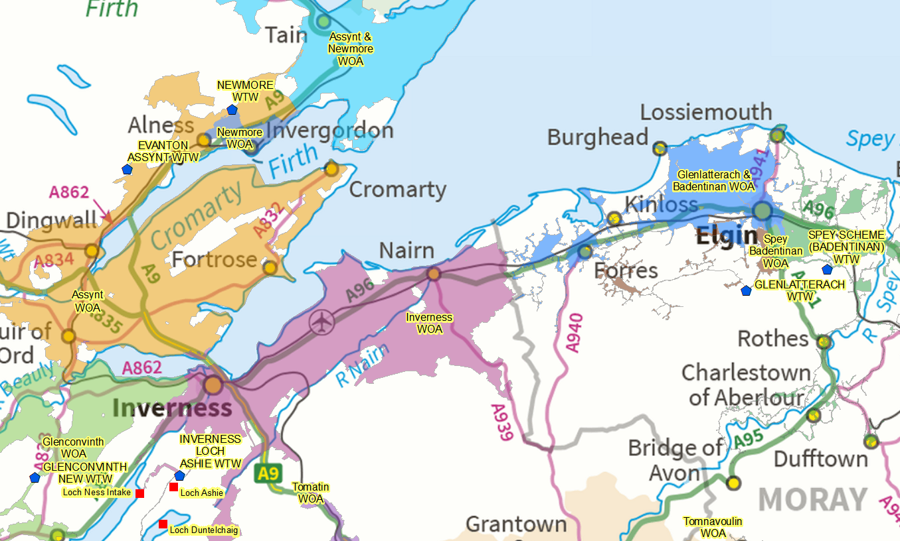

The all hazards resilience assessment for the Inverness and Assynt supplies have only recently been completed, and the range of investment options to improve resilience have still to be appraised. It is a clear possibility that we may wish to connect Inverness to Assynt and maybe Glenconvinth supplies in the future with the potential whenever these WTW are due for replacement to rationalise further if appropriate. Therefore, in consideration of any options there is future value, probably 10-20 years from now, of the potential to send supplies from Inverness to these other systems. This may require up to an additional 18Ml/d of treatment and raw water capacity.

Given the range of uncertainties set out above we have considered the timing and mix of intervention options that may be appropriate and tested the sensitivity of our investment decision to our underlying assumptions about the long term future.

Table 1 sets out our summary of the needs for the Inverness supply area.

**Table 1: Summary of Inverness supply system needs**

|  |  |
| --- | --- |
| Need | Description |
| Security of supply | Drought resilience against historic events is below policy standard of 2.5%, and worst ranking zone across SW impacting 1.7 SoSI points. There is a 2 to 5% chance of supply interruption by 2027.  Once demand reaches 30Ml/d we are effectively draining the loch. |
| Environment | At current demand with no further development permitted, there is a 2% to 5% chance of fish passage/compensation interuption by 2023. If growth continues as per the range modelled scenarios the risk increases. |
| Economic growth | Last 10 years 500 houses pa growth. Forward prediction between 500-750 house per annum - if we allow this the timescale to interruption to fish passage/compensation is shortened by 1 to 2 years and there is 5% or worse risk of supply restrictions between 2024 to 2026 and increase to risk of supply interruption to up to 25% by 2029 |
| Water quality | No significant water quality improvement needs identified |
| Wider regional supplies resilience | Assynt system has resilience deficiencies, still to be appraised as part of strategic connectivity plan. Expect there will be a likelihood of connecting Assynt, Glenconvinth and Inverness in long term resilience strategy |
| Asset replacement | 20 year old membrane plant - long civils asset life remaining, ongoing M&E maintenance / equipment replacement  Full plant replacement likely to be 40 -60 years from now. |

## Options Appraisal

In 2015, we decided to progress with a new 40ML/d raw water source from Loch Ness. At that time for the marginal extra cost (£2m) over a 20ML/d raw water supply, it was deemed ‘beneficial’ to have raw water capacity that provided resilience to contamination of the existing sources, climate change and could support a potential future upsizing of Inverness WTW to provide resilience to other supplies.

Given the increased up front construction cost of the developed option, our Strategic Plan aims and SEPA’s One Planet Prosperity plan, we have reviewed the options further to confirm if this is the appropriate solution to take forward.

Our standard approach to addressing supply demand risk is to consider in the following order;

1. Demand side reduction SW assets – leakage reduction, process losses and wastage
2. Demand side reduction customer – reduction in daily consumption and customer side leakage
3. Systems connectivity production planning – opportunities to move demand to other systems
4. Additional supply capacity

We reviewed demand side management options to improve resilience of the existing supply and meet ongoing demand increase and found that these cannot fully meet the immediate supply resilience deficit to policy level or longer term demand challenges. However, given that this supply is sensitive to a multi-year dry period there is merit in pursuing these as risk mitigations that allow deferment of the investment to improve supply resilience. These are grouped as Option 1 in Table 2, our assessment is that we should pursue **Option 1b** - leakage reduction of a further 2Ml/d and initiate a water efficiency campaign as these provide a good value return for the resources invested. The water efficiency campaign will give us greater understanding of the benefits of this activity on a large scale, building from the water efficiency pilots we have undertaken in the past. Those small scale pilots assessed a 2 to 5% reduction in domestic demand was acheiveable. We recognise this is still much higher PCC than in metered supplies in E&W but do not believe metering is a good value investment to manage supply demand deficit in this system, given the longer term considerations.

We investigated connecting to nearest adjacent supplies, Glenconvinth WTW and Assynt WTW but determined that even along with demand side management there was inadequate capacity to meet future demands and climatic risks and this would reduce resilience of the Assynt supplies. At best these would delay the need to invest in additional supplies rather than avoid it. Also this was a relatively high cost / Ml/d so of lower overall value.

That left us to consider the best options to ensure a reliable and resilient supply for Inverness by increasing the availability of water at the existing Inverness WTW allowing its capacity to be fully exploited, in line with circular economy goals, or building a new standalone supply fed from Loch/River Ness to reduce demand on Inverness WTW sources and meet future growth. These are grouped as option 2 and our assessment is that when we reach the point that we need to increase supply resilience.

We have assessed that **Option 2f -** **40Ml/d pumped raw water supply** to the existing Inverness WTW from Loch Ness is constructed to meet future demand and climate change impacts, and provide flexibility for future supply resilience to the surrounding areas at the lowest net present cost with greatest flexibility to deal with future uncertainties. It is recommended that we undertake phased installation of the capacity within the pumping station to align with the demand increases and reduce the whole life costs and upfront costs. This could be done in 10Ml/d increments every 10-15 years as demand increases and climatic changes dictate (install 2 pumps initially and remaining 3 in stages). This modular approach reduces the whole life cost whilst providing a reliable supply for Inverness and the surrounding area and avoids any repeat construction carbon in 30-50years for extending the 20Ml/d option. This also reduces the investment up front allowing other benefits to be delivered across our portfolio whilst still supporting the lowest cost approach in the long term.

We also looked at potential new WTW utilising sea water on Moray Firth but ruled this out due to the high cost of treatment process required for the saline water and the associated carbon.

Table 2 summarises the relative merits of options considered against our strategic ambitions.

Table 2: Options summary comparison

|  |  |  |  |  |  |  |  |
| --- | --- | --- | --- | --- | --- | --- | --- |
| Option | 60 year NPC - £m | | | Service excellence | Net zero emissions | Value - NPC £m/  ML/d | Comment |
| low | mid | high |
| Base – maintain existing WTW @ Inverness | 33 | 40 | 48 |  |  |  |  |
| Option 1a - Leakage reduction | 34 | 42 | 49 | Not met - only provides 2Ml/d | Reduces emissions | 0.8 | Interim risk mitigation and deferral enabler |
| Option 1b - Leakage & Water efficiency campaign for PCC reduction | 35 | 43 | 51 | Not met - Uncertainty of benefits – assumed 2.5Mld | Could reduce emissions | 0.8 | Interim risk mitigation and deferral enabler |
| Option 1c - Leakage & customer metering for PCC reduction | 54 | 66 | 78 | Not met - Uncertainty of success, up to 6Ml/d | carbon of meter install and replace? | 4.3 | Metering to reduce PCC is not a good investment |
| Option 1d – Leakage reduction and link to Assynt WTW | 59 | 70 | 91 | Not met provides 7Ml/d  reduces Assynt resilience | High | 4.3 | Low value, high cost not worth pursuing even to defer the raw water investment |
| Option 2a - new 20Ml/d raw water source from Inverness | 80 | 93 | 106 | Met until 2050 -2065 | High | 2.7 | Does not provide full flexibility for future scenarios |
| Option 2b - new 40Ml/d source and WTW capacity increased 2065 | 87 | 101 | 116 |  | High | 1.5 | Original option selected |
| Option 2c - new 20Ml/d source augmented in 30 years from Inverness and WTW capacity increased 2065 | 95 | 110 | 126 | Met until 2050 | High & repeated | 1.8 | Not lowest WLC |
| Option 2d - new 20Ml/d source augmented in 50 years from Inverness and WTW capacity increased 2065 | 88 | 102 | 117 | Meets all future scenarios | High | 1.6 | Tipping point WLC for 20 vs 40 now |
| Option 2e - 40Ml/d raw water source initial 20Ml/d PS capacity, WTW and PS capacity increased 2065 | 84 | 98 | 113 | Meets all future scenarios | High | 1.5 | Lowest NPC option if we choose to build now to meet all future scenarions |
| Option 2f - defer by 10 years, 40Ml/d raw water source initial 20Ml/d PS capacity, WTW and PS capacity increased 2065 | 70 | 83 | 95 | Meets all future scenarios | Not as high | 1.1 | Allows for 5% chance of drought actions until outflows exceed inflows in loch |
| Option 3 - New source & WTW at new location, 20Mld raw in 45 years | 100 | 124 | 147 | Meets the demand | Highest | 2.1 | High cost and delay risk for planning timescales |

From Table 2 we can see that the marginal NPC of Option 1b to Base scenario is £3m. By undertaking Option 1bwe should allow ourselves the ability to permit growth for around 6 to 10 years with no change to current service risk. By inspection of Table2 the difference in NPC between Option 2e and Option 2f is £15m, so it would seem a worthwhile investment to undertake Option 1b to see a net NPC reduction of up to £12m with no increase to service risk.

Further assessment of the economic benefits of deferment of option 2f show that for additional deferment of 5 years beyond the initial assumed 10 years there is approximately £1m of NPC benefit each year. Therefore, assuming that annual growth is 0.2 to 0.3Ml/d it would be of value to reduce leakage beyond the 2Ml/d in option 1b, and take it as low as technical possible unless the average cost per Ml of reduction exceeds £3m/Mld. We currently work on an average cost of £0.25m/Ml/d for leakage reduction, so there is plenty of headroom for further activity to deliver long term economic benefit.

## Recommendation

We recognise there are a number of uncertainties surrounding future demand and climate change and have considered a number of scenarios that also consider the future resilience strategy. We have appraised a number of options and phasing to assess the lowest net present cost and least regrets investment.

Therefore, we propose the following risk management approach

1. Confirm with SEPA that it is environmentally acceptable to delay the investment as long as possible (lower carbon) accepting that fish passage may be interrupted (5-25% chance)
2. Undertake demand side management improvements (option 1b and beyond) to support current service and environmental risk reduction and allow deferment of full resilience scheme as long as possible.
3. Undertake annual review of supply demand balance to monitor the situation and invoke risk management actions as required in drought management plan as follows
4. If demand is below 29ML/d and fish passage is interrupted – instigate siphon for compensation flows (4.5Ml/d) and decide whether to install under-pumping arrangement or proceed with the full resilience scheme (option 2f).
5. If average annual demand reaches within 1 Ml/d (3to 4 years at current growth rates) of the sustainable average inflows (currently 29Ml/d but may reduce depending on climate change effects) instigate delivery of full resilience scheme (option 2f)

As time progresses the use of the pumping will increase as demand grows in the area, however the longer we can defer the initiation of the scheme the more the operational carbon impact of this is likely to be offset by the ongoing ‘greening’ of the electricity supply network.

# Appendix 1 – Water supply reliability assessment

1. **Hydrological background**

Inverness WTW is supplied by a blend of Loch Duntelchaig (85%) and Loch Ashie(15%) to optimise the treatment process and manage environmental issues at Loch Ashie. We have a CAR licence which allows us to abstract 42 Ml/d from the combined sources and requires a compensation flow from Loch Duntelchaig of 4.54 Ml/d. There is no current CAR licence condition for compensation at Loch Ashie but SEPA require compensation to be delivered with any new water resource scheme.

Loch Duntelchaig has a total storage of 144,402Ml/d with a maximum depth of 65m. Only a small proportion of the storage is utilised for water supply. Useable storage is constrained by the operating level of the fish pass at -1.34m providing 7,373Ml (defining the current yield) or the intake level of -2.5m providing 13,646Ml.

In addition to these physical constraints there are hydrological constraints on the yield:

* it is located in a low rainfall area of Scotland;
* it has a small catchment area in comparison to its volume;
* it has a large surface water area which leads to large amounts of open water evaporation.

For these reasons, the loch is susceptible to drawdown and poor refill over consecutive dry years such as those experienced in the 1970s.

***When demand exceeds 30Ml/d it is greater than the long term net inflow. This is the tipping point in average conditions beyond which the Loch Duntelchaig no longer refills.***

Because Loch Ashie is used sparingly in the raw blend of water at the treatment works, Ashie tends not to fail in current or future demand scenarios. However, if the proportion of demand supplied from Loch Ashie were to increase it would exhibit the same drawdown sensitivities we see at Loch Duntelchaig. *See Section 6 Environmental Constraints.*

1. **Historic rainfall trends in catchment**

Historic rainfall trends reveal a number of multi-year dry spells in Inverness. Figure A1.1 shows a nine year period in the 1970s with consecutively below average annual rainfall and a similar eight year period in the 1940s. With the current and future demand scenarios there would be a risk of losing supply to our customers if we had a number of consecutive dry years.

Figure A1.1: Historic rainfall trend in Inverness catchment

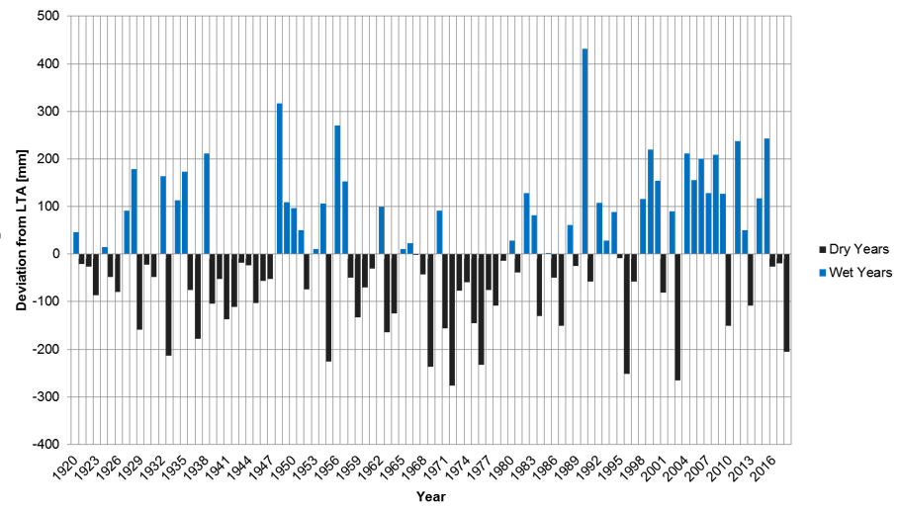

1. **Climate change**

As can be expected any climate change projection contains uncertainty, with the range of climate change scenarios showing an overall range of +5Ml/d to -15Ml/d change to water availability by 2080 in a 1in40 return period drought (2.5% chance in any year) as shown in Figure A1.2.

Figure A1.2: Forecast changes to existing yield under climate change scenarios

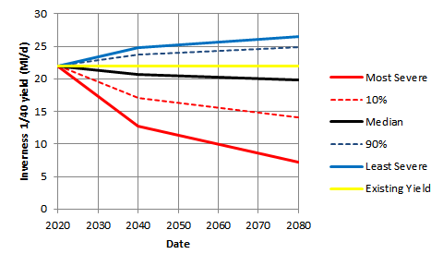

In summary against a 1in40 drought return period:

* By 2040 the median forecast reduction is 0.8Ml/d
* By 2040 10% risk of yield reduction greater than 4.9Ml/d
* By 2080 the median forecast reduction is 2.2 Ml/d
* By 2080 10% risk of yield reduction greater than 7.9 Ml/d

1. **Demand growth projections**

The 2019/20 average annual demand in the Inverness Water Resource Zone (WRZ) was 24.4Ml/d. With the inclusion of raw water losses, the total demand for raw water is 25.0Ml/d. With raw water blending, Loch Duntelchaig provides 21.3Ml/d of current raw water demand.

Future scenarios described below, we have assumed that PCC remains the same. The PCC in the zone is currently 175l/h/d and has risen in past few years. This is slightly above the Scotland average of 166l/h/d, which is consistent with the average non-metered consumption across the UK water companies. The lowest reported average PCC across UK is 135l/h/d in companies that have high meter penetration.

If PCC was reduced to the lowest company average in E&W this could provide 3 to 4 Ml/d reduction in demand. It is likely we would require a high level of metered customers to achieve this level. Given this is could not be achieved in short term we have excluded it from modelling scenarios but do consider it within our option phasing.

In future scenarios described below, we have used two demand forecasts; a lower historic rate equal to that seen over the past 10 years (500 houses pa); and a higher rate based on Developer Management Team’s assessment of current applications, known plans and future area plan (750 houses pa).

Figure A1.3 Inverness Assumed Demand Growth

1. **Scenario modelling**

To assess the security of supply in years to come we have run a number of simulations using weather, demand and climate change data. This allows us to test the sensitivity of each scenario against current source availability and future options.

Our water resource modelling uses:

* Observed weather patterns over the last 100 years;
* Demand scenarios based on local authority projections, historic rates and actual known developments in the short to medium term;
* Climate change scenarios using the median and 10 percentile predictions from UKCIP09 to assess change to yields in the future.

In any modelling exercise it is also necessary to make assumptions and generalisations about the system in question.

Our water resource modelling assumes:

* Lochs Duntelchaig and Ashie continue to be used in a 85:15 blend ratio;
* Headroom is not included in the assessments below. Headroom is assumed in the business’s supply demand balance assessments;
* For ease of scenario modelling, climate change impacts are represented as a component of demand increase rather than adjusting yields.

Results of this exercise are discussed in the remainder of this Appendix. Eleven scenarios were modelled, as shown in Table A1.1, with the results of Scenarios 1-5 shown in Table A2.2 and scenarios 6-1 in Table A2.3. Graphs of modelled results are shown for selected scenarios only.

**Table A1.1 Hydrological Modelling Scenarios**

|  |  |  |  |  |  |
| --- | --- | --- | --- | --- | --- |
| Scenario | Figure | Demand Scenario | Leakage Scenario | Climate Change Scenario | Ness Pumping |
| 1 | A1.5 | Current Demand |  | None | None |
| 2 |  | High Growth |  | Median | None |
| 3 | A1.6 | High Growth |  | 10%ile | None |
| 4 |  | Historic Growth |  | Median | None |
| 4A | A1.7 | Historic Growth | Reduction | Median | None |
| 5 |  | Historic Growth |  | 10%ile | None |
| 6 |  | High Growth |  | Median | 20 Ml/d |
| 7 | A1.8 | High Growth |  | 10%ile | 20 Ml/d |
| 8 |  | Historic Growth |  | Median | 20 Ml/d |
| 9 | A1.9 | Historic Growth |  | 10%ile | 20 Ml/d |
| 10 |  | High Growth |  | 10%ile | 40 Ml/d |

The risk to supply and compensation/fish pass failure under each scenario is illustrated in each projection. They show the risk of Loch Duntelchaig being ***below*** a particular storage level in the future based on a given demand/climate change/investment scenario. The 98% risk line is indicative of reservoir storage that would be expected under unusually wet conditions, while the 2% risk line is indicative of the storage that would be expected under very dry conditions. The plots also show the expected change in demand over time, represented by the blue area and the values on the right hand *y* axis.

* 1. ***Projection Scenarios - Current Demand***

To provide some context of the risk, Figure A1.4 shows the modelled time sequence of reservoir storage between 1920 and 2018 assuming current demand. This reflects the impact of the low inflows during the 1970s.

**Figure A1.4: Modelled time sequence of reservoir storage between 1920 & 2018 reflecting the impact of the inflows during the 1970s.**

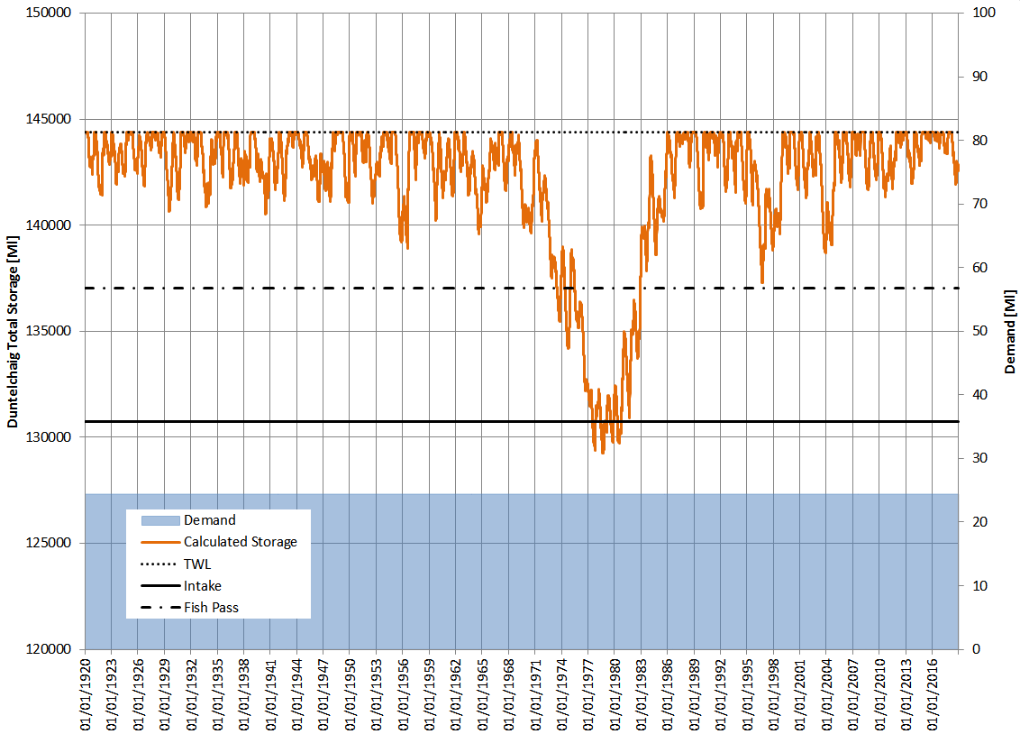

The key message is that we would only see sustained supply and environmental issues if a multi-year event, similar to that witnessed in the1970s, occurs in the future.

Figure A1.4 shows that at current demand the loch would refill after a severe drought event but it would be:

* below top water level (no spill providing downstream flow variation) for 17 years
* below the fish pass/compensation provision continually for 7 years and intermittently for up to 10 years
* below the supply intake for different durations over a 5 year period (“supply failure without action”) r.

Management of such an extended low flow period would require timely drought plan intervention to minimise environmental impact and prevent supply failure:

* siphon installation or sustained under-pumping of the compensation flow
* agreement from SEPA to vary CAR licence to cease providing passage for fish
* sustained under-pumping of storage from below the intake into supply.

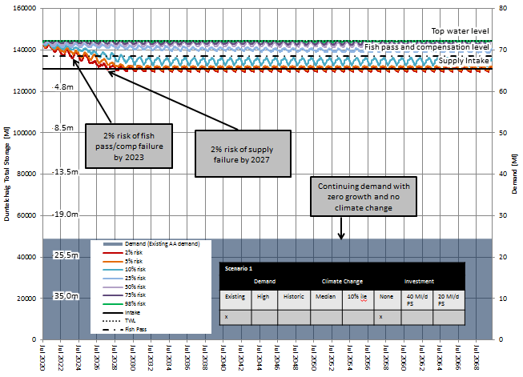In summary, while the chance of failure at Duntelchaig is low under current demand, the customer, environmental and operational consequences could be significant due to the long duration of the failure event. *See Section 6 Environmental Constraints.*

Scenario 1: Current demand

Figure A1.5 demonstrates the impact of consecutive dry years showing a low but constant risk of failing the fish pass or the supply intake.

Figure A1.5: Scenario 1: Risk to future raw water storage based on current demand, no investment, no climate change

From this scenario there is:

* 2% to 5% risk of fish pass and compensation failure in 3 years;
* 2% to 5% risk of supply restriction and under-pumping in 7 years;
* there is an ongoing 10% risk of fish pass/compensation failure, and a 2-5% risk of supply restriction requiring under-pumping.
* in most years Loch Duntelchaig storage will not reach the fish pass

In summary, Figures A1.4 and A1.5 show that if we were to have a drought similar to the 1970s, we would have to act within 3 years to prevent the risk of failing the fish pass and compensation flow, and within 7 years to prevent higher than acceptable risk to supply interruption.

* 1. ***Projections Scenarios with changing demand:***

We already know that demand is increasing in the zone, so we have modelled the impact on the risk to supply and the environment, both at the historic and higher assessed rates of growth, and at median and 10%ile climate change predictions as per Table A1.1 above. Scenario 3 and 4a are shown below for illustrative purposes.

Scenario 3: High growth, 10th percentile climate change and no investment

This is seen as the worst case scenario, assuming high growth rates continue indefinitely and that climate change is at most impactful end of the scenarios within UKCIP09 ,10%ile prediction.

**Figure A1.6: Scenario 3 Risk to future raw water storage based on supply demand balance forecast – high growth, 10%ile climate change prediction and no investment**

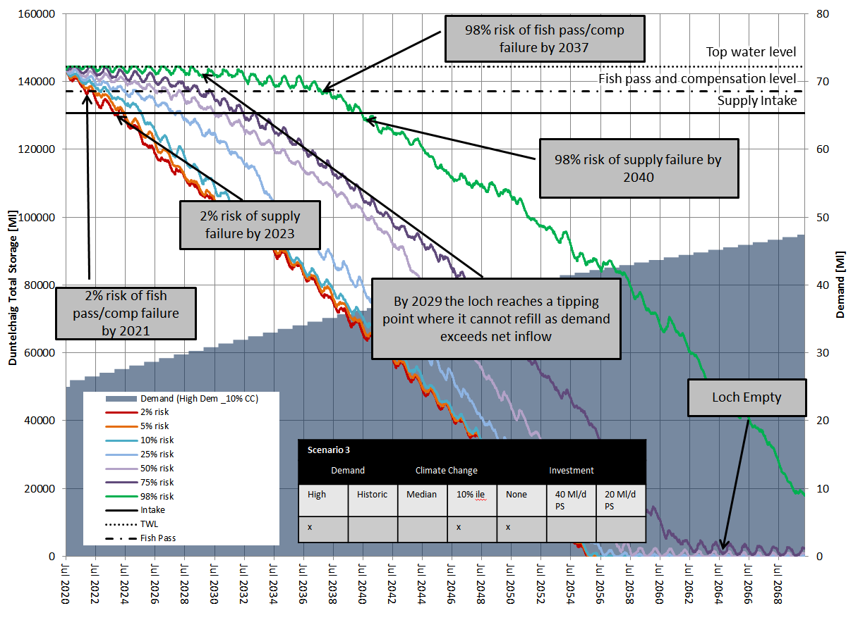

From figure A1.6 we predict that:

* 2% chance of cessation of the fish pass and under–pumping of compensation would occur in 2021
* 25% chance of cessation of the fish pass and under–pumping of compensation would occur by 2024
* 2% chance of ‘supply failure’ in 2023 requiring under-pumping
* 25% chance of ‘supply failure’ in 2028 requiring under-pumping
* by 2029 the demand is such that refill is almost certain not to occur and the loch draws down permanently over the next 20-30 years. This provides an initial backstop timeline for improvement.
* 50% risk of emptying the loch by 2058
* As demand increases the time to deliver a capital scheme reduces

Scenario 4a: Historic growth rates, median climate change prediction and leakage reduction

This scenario looks at more optimistic long term scenario to understand the range of timescales over which we might have to act. It also takes account of the benefit of a further 2ML/d leakage reduction.

Figure A1.7: Scenario 4a Risk to future raw water storage based on supply demand balance forecast – historic growth, median climate prediction & 2Ml/d leakage reduction

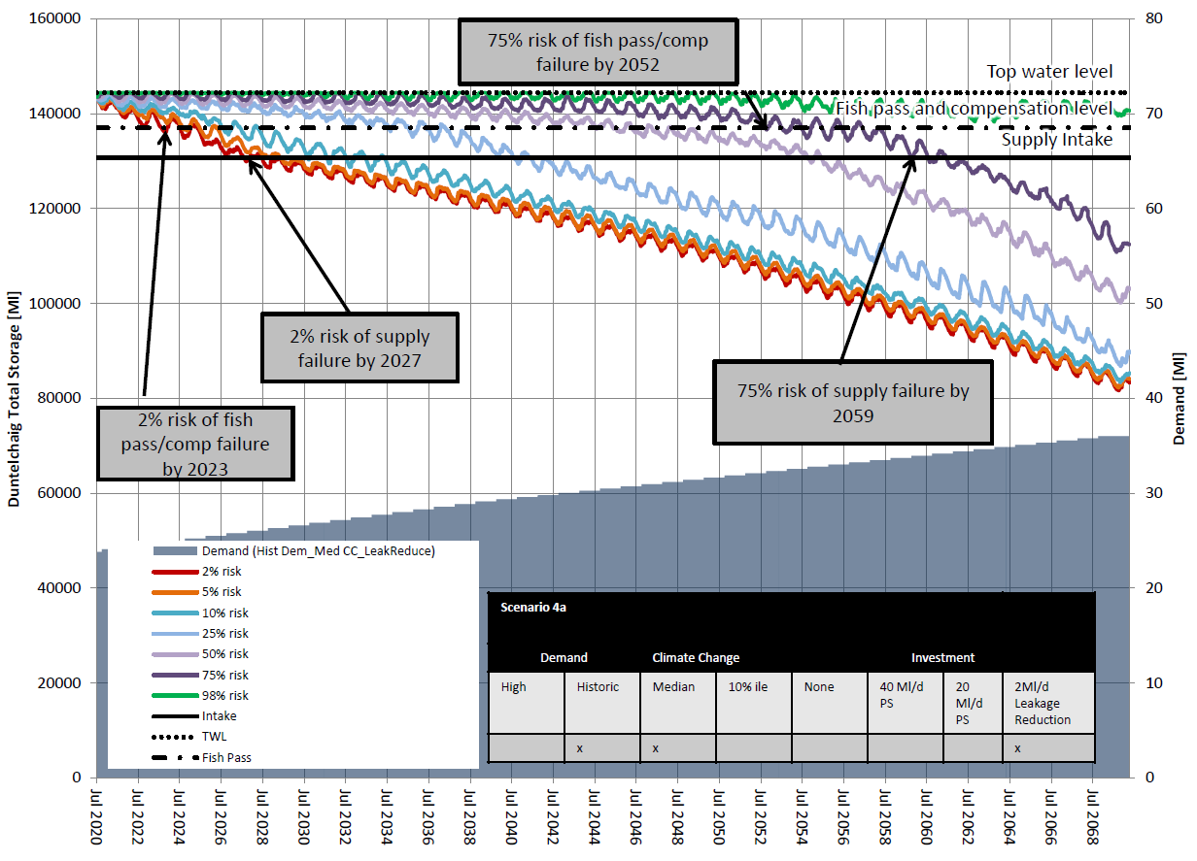

From Figure A1.7 we predict that:

* 2% chance of failure of the fish pass and under–pumping of compensation would occur by 2023
* 25% chance of failure of the fish pass and under–pumping of compensation would occur by 2034
* 2% chance of ‘supply failure’ in 2027 requiring under-pumping
* 25% chance of ‘supply failure’ in 2040 requiring under-pumping
* by 2044 the demand is such that refill is almost certain not to occur and the loch draws down permanently over a number of decades. This provides an initial backstop timeline for improvement.
* delivering a 2ML leakage reduction delays the supply failure at the 2% risk profile by 2-3 years.
  1. ***Summary of Projections without investment:***

Table 2.2 shows a summary of the time until failure of the fish pass and supply intake at the risk profiles for the different scenarios 1-5.

**Table A2.2 Summary of Loch Duntelchaig Risk of Failure timelines for Scenarios 1-5**

|  |  |  |  |  |  |  |  |  |  |  |  |  |  |  |  |  |
| --- | --- | --- | --- | --- | --- | --- | --- | --- | --- | --- | --- | --- | --- | --- | --- | --- |
| **Scenario** | **Description** | **Year to failure of fish pass/compensation flow at given risk profile from 2020** | | | | | | | **Year to failure of supply intake at given risk profile from 2020** | | | | | | | **Tipping point**  **of loch not recovering\*** |
|  | **Risk profile (%)** | **2** | **5** | **10** | **25** | **50** | **75** | **98** | **2** | **5** | **10** | **25** | **50** | **75** | **98** |  |
| 1  Fig.A1.5 | Current demand | 3 | 4 | 6 | never | never | never | never | 7 | 10 | never | never | never | never | never | n/a |
| 4A  Fig.A1.7 | Hist growth/ median cc/ leakage red. | 3 | 4 | 6 | 14 | 25 | 32 | never | 7 | 8 | 10 | 20 | 34 | 39 | never | 31 |
| 4 | Hist growth/ median cc | 2 | 3 | 4 | 10 | 15 | 24 | 30 | 5 | 6 | 7 | 12 | 23 | 29 | 34 | 26 |
| 5 | Hist growth/ cc 10% | 2 | 3 | 5 | 9 | 13 | 17 | 21 | 5 | 6 | 7 | 13 | 18 | 21 | 25 | 18 |
| 2 | High growth/  cc median | 1 | 2 | 3 | 4 | 7 | 10 | 20 | 3 | 4 | 6 | 8 | 12 | 15 | 24 | 17 |
| 3  Fig.A1.6 | High growth/  cc 10% | 1 | 2 | 2 | 4 | 6 | 9 | 17 | 3 | 4 | 5 | 7 | 10 | 12 | 20 | 9 |

Red=Fish Pass Failure in 1-3 years & Supply Intake Failure 3-6 years ,

Amber=Failure in 4-10 years,

Yellow=Failure 1-20 years,

Green=Failure >20 years or never

*Outer envelope tipping point by which we know the reservoir will never recover as inflows will have exceeded 30 Ml/d demand

The results in Table A2.2 show:

* For all scenarios, there is a low risk (2%) that we will reach the compensation/fish pass level in 1-3 years and the supply intake level in 3-7 years.
* a 2 Ml/d reduction in demand through leakage will push these low risk timescales out by 1-2 years
* there is a tipping point when average inflows are exceeded by demand and the loch will not recover when the total demand exceeds 30 Ml/d. This can be described as the backstop date for investment under any scenario. If we reduce leakage by 2Ml/d this could be between 2031 and 2043 depending on growth rates and climatic effects

As the supply is susceptible to a multi-year dry period event there is an opportunity that the long term solution could be deferred to optimise investment and minimise carbon emissions. This does carry the risk of environmental impact while the project is being delivered and would have to be agreed with SEPA. Critical to this is an agreement with SEPA that deferring/reducing carbon emissions is more beneficial than the environmental impacts of the fish pass being out of action for a number of years if certain conditions prevail, the storage level in the reservoir being lower than previously experienced, the compensation flow being pumped and there being no variation in flow on the downstream watercourse for many years. As demand increases the lead time to failure will decrease so an annual assessment to update the risk being carried and the timelines for intervention is recommended.

Implementing a rule set to monitor and decide when to act on project delivery is suggested below. This is based on the assumption that delivering the long term solution project will take 2-3 years and that we design and have ready to implement the intake modifications or under-pumping arrangements (if appropriate) to ensure continuity of compensation and supplies. This is subject to confirming with SEPA that it is environmentally beneficial to delay the investment as long as possible (lower carbon) accepting that fish passage will be interrupted

1. Design and cost estimate of under-pumping of up to 35Ml/d to be completed with appraisal against full resilience scheme to confirm which mitigation is most appropriate under 4
2. Undertake annual review of supply demand balance to monitor the situation and invoke risk management actions that follow
3. If demand is below 29ML/d and fish passage is interrupted – instigate pumping of compensation flows (4.5Ml/d) and decide whether to install under-pumping arrangement or proceed with the full resilience scheme.
4. If average annual demand reaches within 1 Ml/d of the sustainable average inflows (currently 29Ml/d but may reduce depending on climate change effects) instigate delivery of full resilience scheme
   1. ***Projections of resilience improvement through investment options***

The following section looks at the effects of an additional 20Ml/d and 40Ml/d supply from Loch Ness. The figures were picked on basis of 20Ml/d supporting the capacity of the WTW and 40Ml/d supporting an augmented supply opportunity for wider area. For the 20Ml/d Loch Ness supply scenario, we have examined the same growth and climate change scenarios as shown in 5.2. As the 40Ml/d additional supply would be sufficient to guarantee against environmental and supply issues in all circumstances to 2070, this option is only assessed against the high growth and 10%ile climate scenario.

Table A2.3 shows a summary of the time until failure of the fish pass and supply intake at the risk profiles for the different scenarios 6-10

**Table A2.3 Summary of Loch Duntelchaig Risk of Failure timelines for Scenarios 6-10**

|  |  |  |  |  |  |  |  |  |  |  |  |  |  |  |  |  |
| --- | --- | --- | --- | --- | --- | --- | --- | --- | --- | --- | --- | --- | --- | --- | --- | --- |
| **Scenario** | **Description** | **Year to failure of fish pass/compensation flow at given risk profile from 2020** | | | | | | | **Year to failure of supply intake at given risk profile from 2020** | | | | | | | **Tipping point**  **of loch not recovering\*** |
|  | **Risk profile (%)** | **2** | **5** | **10** | **25** | **50** | **75** | **98** | **2** | **5** | **10** | **25** | **50** | **75** | **98** |  |
| 10 | High growth/cc 10% / 40ML | N | N | N | N | N | N | N | N | N | N | N | N | N | N | N |  |  |  |  |  |  |  |  |  |  |  |  |  |
| 8 | Hist growth/ cc median/ 20ML | N | N | N | N | N | N | N | N | N | N | N | N | N | N | N |  |  |  |  |  |  |  |  |  |  |  |  |  |
| 9  Fig.A1.9 | Hist growth/ cc 10%/ 20ML | 43 | 46 | 48 | N | N | N | N | N | N | N | N | N | N | N | N |  |  |  |  |  |  |  |  |  |  |  |  |  |
| 6 | High growth/ cc median/ 20ML | 46 | 48 | N | N | N | N | N | N | N | N | N | N | N | N | N |  |  |  |  |  |  |  |  |  |  |  |  |  |
| 7  Fig.A1.8 | High growth/  cc 10%/ 20ML | 34 | 36 | 37 | 45 | N | N | N | 42 | 46 | 49 | N | N | N | N | N |  |  |  |  |  |  |  |  |  |  |  |  |  |

Red=Fish Pass Failure in 1-3 years & Supply Intake Failure 3-6 years , Amber=Failure in 4-10 years, Yellow=Failure 1-20 years, Green=Failure >20 years or never

*Outer envelope tipping point by which we know the reservoir will never recover as inflows will have exceeded 30 Ml/d demand

The scenarios with investment as you would expect deliver a source that will not fail well into the future for the predicted demands. These modelling scenarios exclude any future demands associated with resilience to Assynt.

In scenario 6, (high growth, median climate change and 20ML new supply) there is a 2 to 5% risk of fish passage and compensation failure by 2067. Supply would be maintained throughout the forecast period. It is important to note that the smaller pumping station would operate more often and as a result the carbon and operational costs would be higher.

This worst scenario we have tested the 20Ml/d new supply against is the combination of high demand and the 10th%ile climate change as shown in Figure

Figure A1.8: Scenario 7 Risk to future raw water storage based on supply demand balance forecast – high growth, 10%ile climate prediction, 20Ml/d new supply

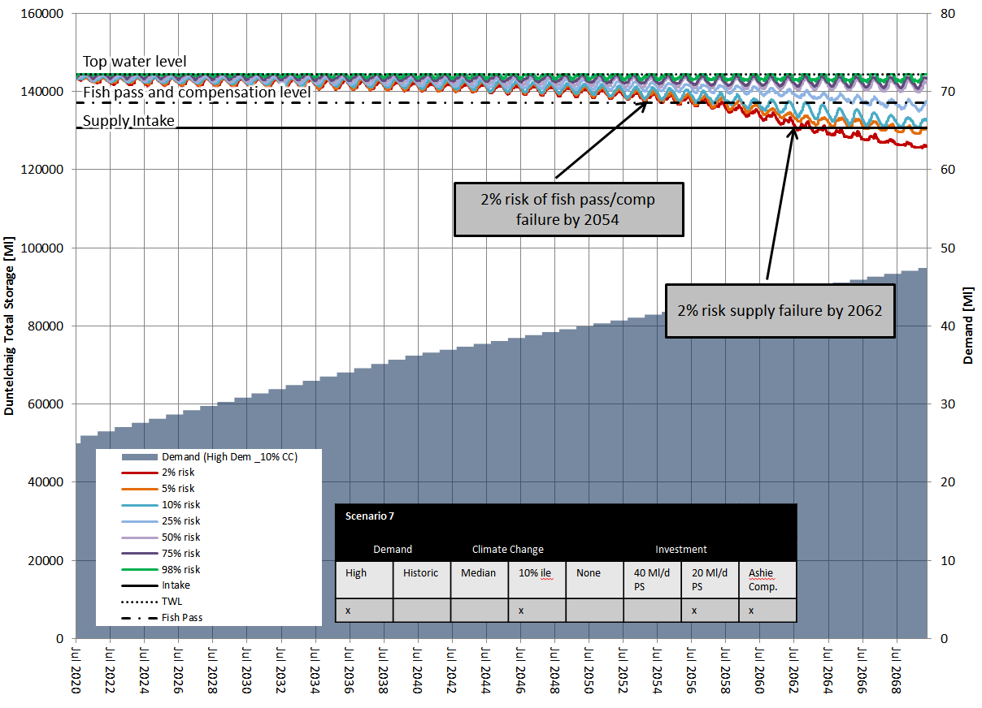

This scenario predicts is a 2% risk of fish pass failure by 2054 and a 5-10% risk of supply failure by 2064.

Figure A1.9 shows the predictions if the growth rates are in line with historic rates rather than the higher rates currently identified.

**Figure A1.9: Risk to future raw water storage based on supply demand balance forecast – historic growth, 10%ile climate, 20Ml/d new supply**

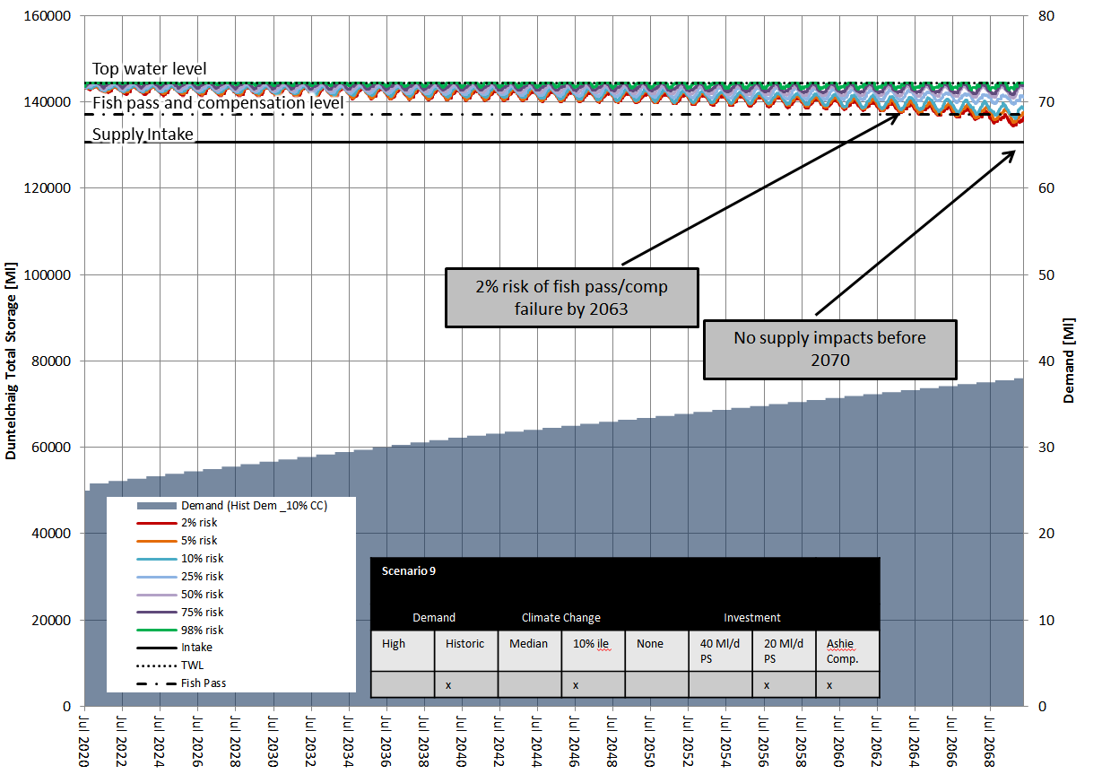

From Figure A1.9 and a1.8 we can see that lower growth rate delays the impact on fish passage by around 10 years with a 2% to 5% risk of fish passage by 2063, and there would be no supply restrictions before 2070.

Scenario 10, (High growth, 10%ile climate change and 40ML new supply) shows there are no supply or environmental impacts before 2070. With the 40 Ml/d supply option, the model optimises on the use of Duntelchaig as much as possible to minimise pumping costs and carbon. This also provides capacity that can be used to support resilience to assynt supplies if required.

1. **Environmental Constraints**

The main environmental constraints of the Inverness system are:

* Loch Ashie has designations for protected species of bird.
* Loch Ashie has known fisheries interests. There is a requirement from SEPA to deliver a compensation flow with the proposed Loch Ness scheme.
* Loch Duntelchaig has a compensation flow requirement and a fish pass
* Through an extended drought Duntelchaig storage could be below the fishpass/compensation level for a number of years. Compensation could be over pumped to provide downstream flow, but the fish would not be able to pass into the loch due to exposed loch sides.
* Loch Duntelchaig discharges into Loch a’ Chlachain downstream. There is an operating fish farm which relies on the compensation flow from Loch Duntelchaig.
* We are required under WFD to maintain outflow variation across the year. We presently pass environmental standards and would continue to do so with a new supply scheme. If we utilise storage between the fish pass and intake levels we will not be able to provide flow variation impacting the River Nairn
* Loch Duntelchaig is a popular, accessible destination for visitors, walkers and fishing community.

1. **Treatment capacity**

Inverness WTW was commissioned in 2002, therefore it has significant remaining life in the civils assets. It is designed to treat 38.5Ml/d which is consistent with the abstraction licence that was in place at the time. The current annual average demand is around 24 ml/d and we forecast that the dry year annual average (DYAA) demand is around 3% higher than this. Dry Year Peak demand is forecast to be 15% higher than average demand.

Figure A2.14 shows the potential timescales for the current treatment capacity to be exceeded against both high and historic growth rates and annual average (AA) and dry year peak (DYP) demands. A leakage reduction volume of 2Ml/d is also assumed. This predicts that the earliest we may have short term capacity issues is 2045 to meet dry year peak demand, however the earliest we may fail to meet average demand is 2065, and if historic growth rates occur rather than high then this will be beyond 2070.

**Figure A2.14: Supply demand balance forecast – WTW headroom capacity utilisation**

1. **Conclusions**

Loch Duntelchaig is a large source but the current configuration of fish passage and raw water intake only enables use of a small proportion of the total volume. There is evidence of extended dry periods in the historic record and should these occur again we would reach levels where we would not only fail fish passage and compensation requirements but ultimately fail to supply our customers.

Therefore, we are more likely to have a greater time to act to guarantee against future environmental and supply issues. If we go into a period of extended dry weather we have between 1 and 2 years to deliver a solution to guarantee compensation and between 3 and 7 years to deliver a solution which will guarantee against supply failure

If either of these events occurs before we have reached the point where the outflows exceed the natural inflows to the loch then our drought management plans would be introduced. Installation of temporary siphons to provide compensation (estimated cost £200-300k, one off) and installation of temporary under-pumping from the loch to provide full water supplies (estimated cost £300 to £500k per annum).

Assuming SEPA are accepting of the interruption to fish passage to gain benefit of carbon reductions, these risk mitigations present an option to defer implementation of a solution until the growth trend and climate change is observed that means we are within 3 years of entering an ongoing drawdown period.

Loch Ness is the largest inland water body in Scotland by volume, and therefore in context of supplying Inverness it would remove all future climate change drought risk to Inverness supply. The other climate resilient source is the Moray Firth which is a saltwater source and would require significantly costlier and energy consuming treatment processes, so was not considered further.

Demand side management reductions in leakage of 2Ml/d (to lowest levels seen in E&W companies) would provide some benefit delaying by about 1 to 2 years the increasing risk associated with demand growth to fish passage prevention or supply restrictions. Neither leakage or longer term PCC reduction will fully address the issues we forecast.

There is also a risk that per capita consumption continues to increase as we see climatic change which could bring forward some of the dates a few years.

An additional 20Ml/d raw water supply would provide resilient supplies at least until 2062 and possibly beyond 2070. It would protect the water environment (fish passage and compensation) at least until 2054 and possibly as long as 2070 depending on the actual growth and climate change scenarios encountered.

An additional 40Ml/d raw water supply provides resilience to all scenarios and an available surplus to support resilience to Assynt and Glenconvinth if decided a priority.

# Appendix 2 – Cost and carbon estimating

We have estimated the costs of each option, the cost of the new 20 and 40Ml/d raw water sources are based on latest best estimates from our Alliance partner CWA for the 40Mld solution that has been developed.

Table A3.1 shows the cost breakdown of the key components of the 40Ml/d project and the assessment of savings that may be seen in the 20Ml/d option, provided by CWa and Costing Services.

Table A3.1: LBE project cost breakdown

|  |  |  |  |  |
| --- | --- | --- | --- | --- |
| Item | £m | 40Mld raw | 20Mld raw | 40Mld fitted at 20Mld |
| Intake | £1.2 | £1.9 | £1.65 | £1.9 |
| Dores RWP | £14.4 | £22.7 | £18.82 | £19.62 |
| Pipelines | £7.2 | £13.6 | £12.87 | £13.6 |
| On-costs & risk | £15.5 |  |  |  |
| **Total** | **£38.2** | **£38.2** | **£33.3** | £35.1 |

Note these figures are still under review by CI team but are broadly correct and adequate for purpose of this appraisal

It can be seen from Table A3.1 that the majority of savings associated with reducing to 20Ml/d are in the costs of the pumping station. The major element of this is £1.5m in the power supply, which has still to be verified. However, if we were to build the pumping station to accommodate 40Ml/d but set up pumping at 20Ml/d (or less) initially it is estimated would cost around £1.8m more than the 20Ml/d option, and give us a future proof solution and flexibility for resilience.

Demand side option whole life costs have been estimated as shown in Table A3.2 with the cost benefit of each of these estimated and compared to the full resilience options. As there is an estimated £8m difference in whole life cost of a 20Ml/d raw and 40Ml/d raw supply (for the benefits accrued from demand side options and their costs they would not appear beneficial to reducing the overall cost of the resilient solution. However, it may be appropriate to undertake leakage activity to reduce supply risk until the recommended solution is commissioned.

Table A3.2: Options cost benefit assessment

|  |  |  |  |
| --- | --- | --- | --- |
| Option | Predicted benefit Ml/d | Estimated WLC £m increase | Cost/benefit ratio £m/Mld |
| Leakage reduction | 2 | 1.6 | 0.8 |
| Water efficiency campaign | 0.5 | 0.9 | 1.8 |
| Customer metering | 4 | 24 | 6 |
| Assynt WTW link | 5 | 27 | 5.4 |
| 20Ml/d raw water supply | 20 | 53 | 2.7 |
| 20Ml/d raw water with future increase of 20Ml/d | 40 | 70 | 1.8 |
| 40Ml/d raw water supply | 40 | 61 | 1.5 |

Water efficiency benefit of 3-5% of demand based on pilot programme in SR15

We have compared the whole life costs of a number of options, and time phasing using the following assumptions about costs for options that were not taken forward.

We have estimated the cost of a new 20Ml/d WTW on River Ness would cost between £45 and £65m including a new intake and land and possible pumping into the network and network reconfiguration, this is based on Tullich WTW (10Ml/d) costing just under £30m for the treatment alone, Invercannie DAF and Clearwater tank at around £50m for 60Ml/d, but not the full treatment process and desktop estimate for Turriff (40Ml/d) with new intake and pumps of over £90m.

We assessed that to connect the Assynt WTW to Inverness would involve around 20-25km of network upgrades including the crossing of the Kessock Bridge, we also allowed for increased 3ML/d storage in the network or WTW to support the increased demand. We made no allowance for pumping at this stage and would develop the scope further if we felt this option was of value. We estimated the cost of this work to be in the order of £25 to £30m for the purposes of this strategic appraisal.

We have assumed that to increase capacity of the 20Ml/d raw water pumping option in the future it will cost similar to the current 20Ml/d solution as all the civils assets would be duplicated, whilst some of the building costs would be reduced such as power which are marginal for strategic estimating.

There is plenty of land around the current Inverness WTW and the building is a simple steel frame construction. So when the time comes that we may need to increase treatment capacity it would be an easy extension to the existing works or new build depending on the age and condition of the whole works, which would be subject of a separate appraisal at the appropriate time. An allowance of £15m (£12-£20m) for increasing the membrane filtration capacity, chemical dosing and building footprint has been made in 2045 within the current appraisal of all options other than the new WTW option.

Figure A3.2 shows the Net Present cost of each of the options, these are only suitable for strategic comparison given the different levels of estimating. The options shown in red do not deliver adequate water to meet future scenarios, the options in orange may or may not succeed depending on the growth and climate change scenarios that occur and green options are future proof as far as we can understand the future.

Figure A3.2: Comparison of options net present costs

Our assessment is that unless the additional 20Ml/d is not needed for more than 50 years after construction (option 2d) it is lower whole life cost to build 40Ml/d raw supply when we decide additional resilience is required (option 2b). It can also be seen that a new raw water source option is lower cost than a standalone treatment (option 3).

This lead us to consideration of building the 40Ml/d option civils structures and pipeline but seek to reduce whole life costs by fitting out the pumping station in a phased manner to match rising demand (option 2e). This defers the instalment of some E&M equipment and reduces future maintenance, reducing the whole life cost of this option further, making it more attractive.

Furthermore given that we are dealing with a multi-year lead time event , we could choose to defer investment and accept the 5% chance of implementing drought management actions until the earliest point when the inflows do not meet the outflows in the loch (c.2029 at earliest). These response and recovery costs have been allowed for in option 2f which demonstrates a much lower net present cost.

Further assessment of the economic benefits of deferment of option 2f show that for additional deferment of 5 years beyond the initial assumed 10 years (option 2g) there is approximately £1m of NPC benefit each year. Therefore, assuming that annual growth is 0.2 to 0.3Ml/d it would be of value to reduce leakage beyond the 2Ml/d in option 1b, and take it as low as technical possible unless the average cost per Ml of reduction exceeds £3m/Mld. We currently work on an average cost of £0.25m/Ml/d for leakage reduction, so there is plenty of headroom for further activity to deliver long term economic benefit.

**Carbon**

At present we are unable to strategically estimate the carbon of each option without developing detailed engineering scopes, so we have made a subjective assessment as follows.

The construction carbon of the 20Ml/d and 40Ml/d pumping options will be largely similar with the 40Mld pumping station being slightly higher due to larger pumping wells and building footprint. However, if we build the civils for 40 Ml/d supply now we avoid the risk of a repeat of the full construction carbon in 30 years or beyond, recognising that construction methods may improve significantly over that period reducing the future carbon in construction, but unlikely to the marginal difference between the 20 and 40Mld options today. The operational carbon of both these options will be broadly similar and is primarily power based emissions, which over time will rise but be offset by the lower emission energy in the grid.

A new WTW on Ness is thought to be higher carbon than the pumping options for the same volume of water given the additional chemical costs and power consumption of treatment process and likely pumping into network.

The demand side options of leakage reduction may reduce overall carbon, but are still developing a whole life model that offsets the carbon of leak repair against the carbon of the water saved to understand the economic balance. If leakage alone would meet the supply resilience requirements then this would be favourable as it avoids the construction carbon of other options, but this is not the case.

Defering the construction to allow for smarter low carbon construction techniques in 10 or more years time and the use of a future greener grid would see a lower carbon impact.